In previous internship, we followed the pipeline created by Luxonis to use Oak D depth with yolo or any detection model for fish length and weight estimation.

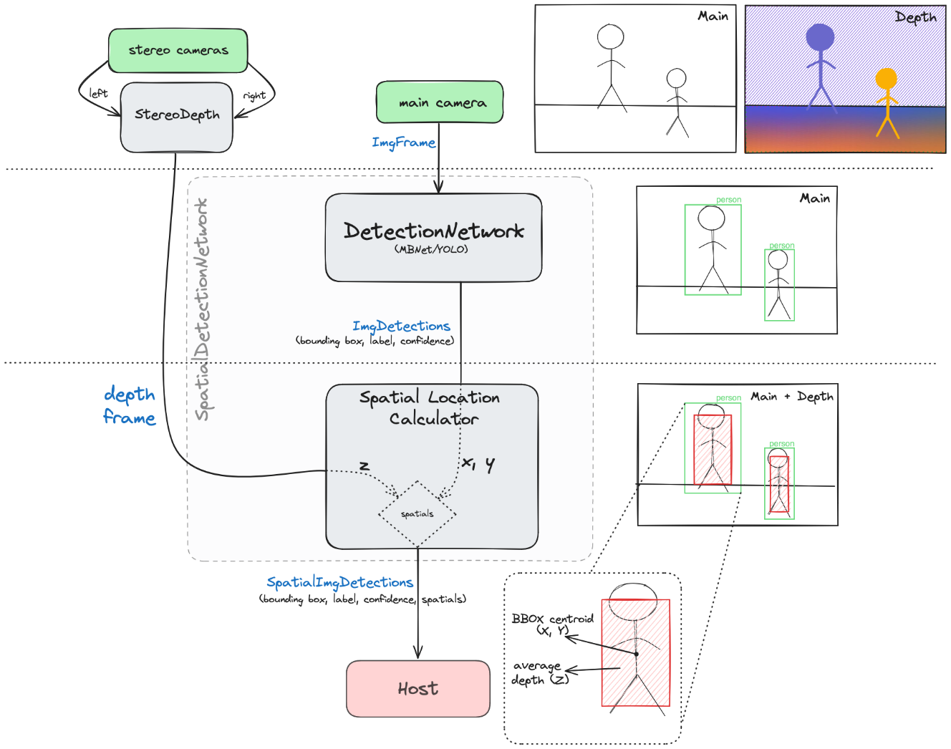

Generally, this approach is widely used as most detection model only support 2d detection.

In the nutshell, we used the length of bounding box as the length of the fish. However, bounding box’s length is in pixel, so we used the depth information given by the OAK-D camera to calculate the real bounding box length and height. After achieving the real length and height of the fish, I used the weight and length relationship formula to estimate the weight of the detected fish. This worked quite well. But of course, there are many draw back as like the inaccuracy and rely on fixed formula that need previous work.

So, for the thesis I propose replacing bounding box with pose estimation for better accuracy. But the problem arise as depthai v2 doesn’t support parsing pose estimation output so you have to create your own decoding. Luckily depthai v3 is out, it supports running pose estimation. So now the biggest problem is how to extract info like the coordinate of each key points for spatial calculation.